Paper/abstract title
Author¹, …, Author*^{,2}
1 Qinghai Minzu University, 3 Bayizhong Road, Xinning, 810007, China
2 State Key Laboratory of Engines, Tianjin University, 135 Yaguan Road, Tianjin, 300350, China
*Corresponding authors
iceai.auto@outlook.com

Abstract
Abstract.

- Introduction
Introduction.

- Methodology
Methodology.

2.1. Method
Method.

$I=I_{0}e^{-\sum_{i}{{(NσT)}_{i}}}$ (1)
$\frac{I_{wet}}{I_{dry}}=e^{-{(NσT)}_{H_{2}O}}$ (2)

- Result and discussion
Result and discussion.
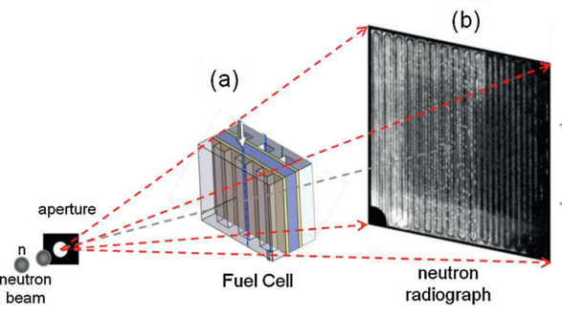
Figure 1. Schematics

Table 1. Parameters
Parameters | Values | Values
Parameter1 | xx | xx
Parameter2 | xx | xx
Parameter3 | xx | xx

- Conclusions
Conclusions.

Reference
- Wang, Y., Seo, B., Wang, B., Zamel, N., Jiao, K., & Adroher, X. C. (2020). Fundamentals, materials, and machine learning of polymer electrolyte membrane fuel cell technology. Energy and AI, 100014.

